CMPEN 331

Lab 5 Report

The Pennsylvania State University

Mrigank Doshy

Access ID: msd5399

1. programCounterAdder

`timescale 1ns / 1ps

module programCounterAdder(

input [31:0] nextPC,

output reg [31:0] PC

);

initial begin

PC=32'd100;

end

always @(*)

begin

PC<=nextPC+4;

end

endmodule

1. instructionMemory

`timescale 1ns / 1ps

module instructionMemory(

input [31:0] PC,

output reg [31:0] instruction

);

reg [31:0] instMemory [0:511];

initial begin

instMemory[100] = 32'b10001100001000100000000000000000;

instMemory[104] = 32'b10001100001000110000000000000100;

instMemory[108] = 32'b10001100001001000000000000001000;

instMemory[112] = 32'b10001100001001010000000000001100;

instMemory[116] = 32'b00000000010010100011000000100000;

end

always @(PC)

begin

instruction<=instMemory[PC];

end

endmodule

1. controlUnit

`timescale 1ns / 1ps

module controlUnit(

input [5:0]op,

input [5:0]func,

output reg wreg,

output reg m2reg,

output reg wmem,

output reg [3:0]aluc,

output reg aluimm,

output reg regrt

);

always @(op, func)

begin

case(op)

6'b100011: //lw

begin

wreg<=1'b1;

m2reg<=1'b1;

wmem<=1'b0;

aluc<=4'b0010;

aluimm<=1'b1;

regrt<=1'b1;

end

6'b101011: //sw

begin

wreg<=1'b0;

m2reg<=1'b0;

wmem<=1'b1;

aluc<=4'b0010;

aluimm<=1'b1;

regrt<=1'bx;

end

6'b101011: //beq

begin

wreg<=1'b0;

m2reg<=1'bx;

wmem<=1'b0;

aluc<=4'b0110;

aluimm<=1'b0;

regrt<=1'bx;

end

6'b000000: //r

begin

case(func)

6'b100000:

begin

wreg<=1'b1;

m2reg<=1'b0;

wmem<=1'b0;

aluc<=4'b0010;

aluimm<=1'b0;

regrt<=1'b0;

end

endcase

end

endcase

end

endmodule

1. mux1

`timescale 1ns / 1ps

module mux1(

input [0:4] rd,

input [0:4] rt,

input regrt,

output reg [4:0] muxRegister

);

always@ (*)

begin

case(regrt)

1'b0: muxRegister<=rd;

1'b1: muxRegister<=rt;

endcase

end

endmodule

1. signExtension

`timescale 1ns / 1ps

module signExtension(

input [31:0] imm,

output [31:0] extendedImm

);

assign extendedImm = {{16{imm[15]}},imm[15:0]};

endmodule

1. registerFile

`timescale 1ns / 1ps

module registerFile(

input clk,

input [4:0] rna,

input [4:0] rnb,

input [4:0] wn,

input [31:0] d,

input we,

output reg [31:0] qa, qb

);

reg [31:0] regFile [0:31];

integer index;

initial begin

for (index=0; index<32; index=index+1)

regFile[index]<=1'b0;

end

always@ (posedge clk, rna, rnb)

begin

qa<=regFile[rna];

qb<=regFile[rnb];

end

always @(negedge clk, rna, rnb)

begin

case(we)

1'b1: regFile[wn]<=d;

endcase

end

endmodule

1. programCounter

`timescale 1ns / 1ps

module programCounter(

input clk,

input [31:0] nextPC,

output reg [31:0] PC

);

always@(posedge clk)

begin

PC<=nextPC;

end

endmodule

1. instructionFetch

`timescale 1ns / 1ps

module instructionFetch(

input clk,

input [31:0] instruction,

output reg [31:0] nextInstruction

);

always@(posedge clk)

begin

nextInstruction<=instruction;

end

endmodule

1. instructionDecode

`timescale 1ns / 1ps

module instructionDecode(

input clk,

input wreg,

input m2reg,

input wmem,

input [3:0] aluc,

input aluimm,

input [4:0] muxRegister,

input [31:0] qa,

input [31:0] qb,

input [31:0] extendedImm,

output reg ewreg,

output reg em2reg,

output reg ewmem,

output reg [3:0] ealuc,

output reg ealuimm,

output reg [4:0] eMuxRegister,

output reg [31:0] eqa,

output reg [31:0] eqb,

output reg [31:0] eExtendedImm

);

always @(posedge clk)

begin

ewreg<=wreg;

em2reg<=m2reg;

ewmem<=wmem;

ealuc<=aluc;

ealuimm<=aluimm;

eMuxRegister<=muxRegister;

eqa<=qa;

eqb<=qb;

eExtendedImm<=extendedImm;

end

endmodule

1. Mux2

`timescale 1ns / 1ps

module mux2(

input [31:0]eqb,

input [31:0]eExtendedImm,

input ealuimm,

output reg [31:0] muxRegister2

);

always@ (*)

begin

case(ealuimm)

1'b0: muxRegister2<=eqb;

1'b1: muxRegister2<=eExtendedImm;

endcase

end

endmodule

1. ALU

`timescale 1ns / 1ps

module ALU(

input [31:00]a, //eqa

input [31:00]b, //output of mux2 - muxRegister2

input [3:0]aluc, //ealuc

output reg [31:00]r

);

always @ (*)

begin

case (aluc)

4'b0010 : r = a + b;

endcase

end

endmodule

1. dataMemory

`timescale 1ns / 1ps

module dataMemory(

input [31:0] a, //r after instructionExecute -rexe

input [31:0] di, //eqb after instructionExecute - eeqb

input we, //mwmem - ewmem after instructionExecute

output reg [31:0]do

);

reg [31:0] dataMemory [0:511];

initial begin

dataMemory[0]<=32'hA00000AA;

dataMemory[4]<=32'h10000011;

dataMemory[8]<=32'h20000022;

dataMemory[12]<=32'h30000033;

dataMemory[16]<=32'h40000044;

dataMemory[20]<=32'h50000055;

dataMemory[24]<=32'h60000066;

dataMemory[28]<=32'h70000077;

dataMemory[32]<=32'h80000088;

dataMemory[36]<=32'h90000099;

end

always@(a, di)

begin

do<=dataMemory[a];

end

endmodule

1. Memory

module Memory(

input clk,

input mwreg,

input mm2reg,

input [4:0]emMuxRegister,

input [31:0]mr,

input [31:0]do,

output reg wwreg,

output reg wm2reg,

output reg [4:0]emwMuxRegister,

output reg [31:0] wmr,

output reg [31:0] wdo

);

always@ (posedge clk)

begin

wwreg<=mwreg;

wm2reg<=mm2reg;

emwMuxRegister<=emMuxRegister;

wmr<=mr;

wdo<=do;

end

endmodule

1. instructionExecute

module instructionExecute(

input clk,

input ewreg,

input em2reg,

input ewmem,

input [4:0] eMuxRegister,

input [31:0]r,

input [31:0]eqb,

output reg mwreg,

output reg mm2reg,

output reg mwmem,

output reg [4:0]emMuxRegister,

output reg [31:0]mr, //r after EXE/MEM,

output reg [31:0]emqb

);

always@(posedge clk)

begin

mwreg<=ewreg;

mm2reg<=em2reg;

mwmem<=ewmem;

emMuxRegister<=eMuxRegister;

mr<=r;

emqb<=eqb;

end

endmodule

1. mux3

module mux3(

input [31:0]wmr,

input [31:0]wdo,

input wm2reg,

output reg [31:0] muxRegister3

);

always@ (*)

begin

case(wm2reg)

1'b0: muxRegister3<=wmr;

1'b1: muxRegister3<=wdo;

endcase

end

endmodule

1. testbench

`timescale 1ns / 1ps

module testbench();

reg clk;

wire [31:0] nextPC, PC;

wire [31:0] instruction, nextInstruction, qa, qb, extendedImm, muxRegister2, do, wdo, muxRegister3;

wire [31:0] eqa, eqb, eExtendedImm, r, mr, emqb, wmr;

wire [4:0] muxRegister, eMuxRegister, emMuxRegister, emwMuxRegister;

wire [3:0] aluc, ealuc;

wire wreg, m2reg, wmem, aluimm, regrt, mwreg, mm2reg, mwmem, wwreg, wm2reg, ewreg, em2reg, ewmem, ealuimm;

initial begin

clk=0;

end

programCounter programCounter_tb(clk, nextPC, PC);

programCounterAdder programCounterAdder_tb(PC, nextPC);

instructionMemory instructionMemory_tb(PC, instruction);

instructionFetch instructionFetch_tb(clk, instruction, nextInstruction);

controlUnit controlUnit_tb(nextInstruction[31:26], nextInstruction[5:0], wreg, m2reg, wmem, aluc, aluimm, regrt);

mux1 mux1_tb(nextInstruction[15:11], nextInstruction[20:16], regrt, muxRegister);

registerFile registerFile_tb(clk, nextInstruction[25:21], nextInstruction[20:16], emwMuxRegister, muxRegister3, wwreg, qa, qb);

signExtension signExtension_tb(nextInstruction, extendedImm);

instructionDecode instructionDecode_tb(clk, wreg, m2reg, wmem, aluc, aluimm, muxRegister, qa, qb, extendedImm, ewreg, em2reg, ewmem, ealuc, ealuimm, eMuxRegister, eqa, eqb, eExtendedImm);

mux2 mux2_tb(eqb, eExtendedImm, ealuimm, muxRegister2);

ALU ALU_tb(eqa,muxRegister2,ealuc,r);

instructionExecute instructionExecute_tb( clk, ewreg, em2reg, ewmem, eMuxRegister, r, eqb, mwreg, mm2reg, mwmem, emMuxRegister, mr, emqb);

dataMemory dataMemory_tb(mr, emqb, mwmem, do);

Memory Memory_tb(clk, mwreg, mm2reg, emMuxRegister, mr, do, wwreg, wm2reg, emwMuxRegister, wmr, wdo);

mux3 mux3_tb(wmr, wdo, wm2reg, muxRegister3);

always

begin

#5

clk = ~clk;

end

endmodule

1. Waveform

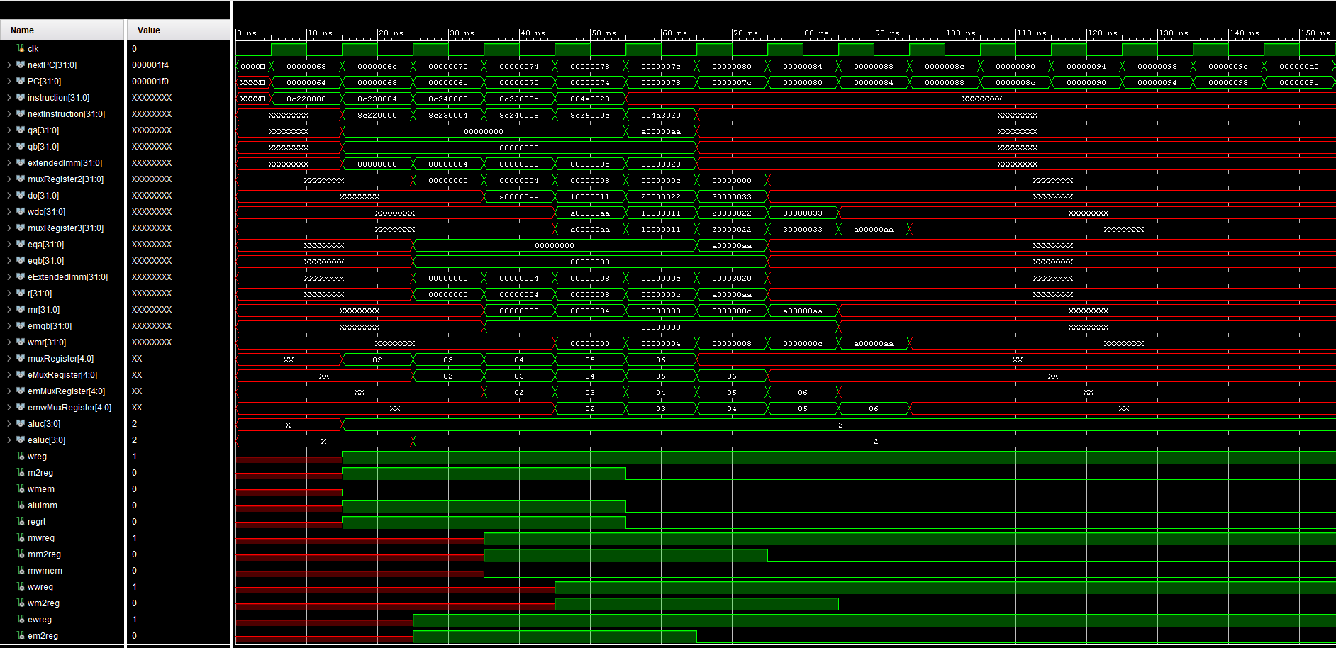

1. Design Schematic

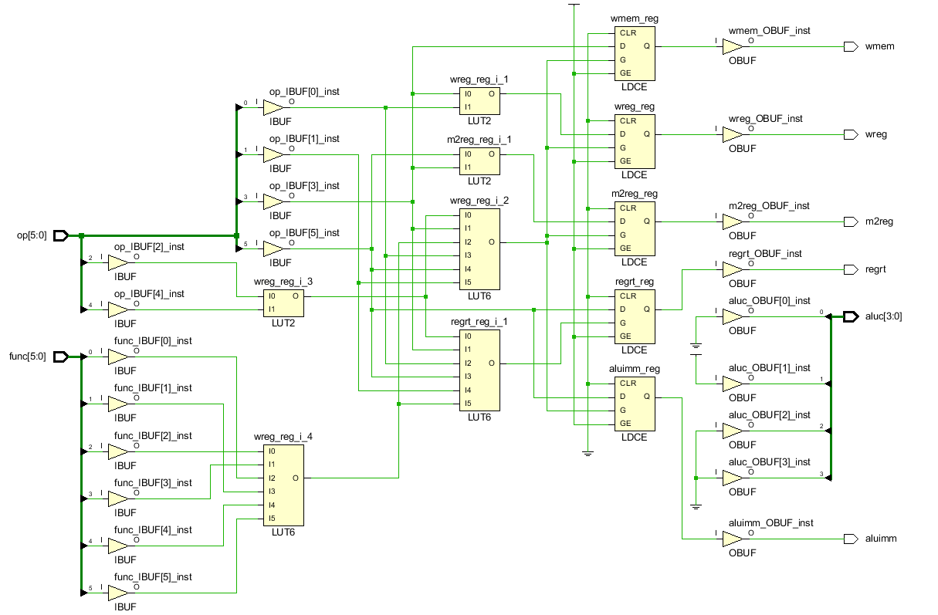

1. I/O Planning

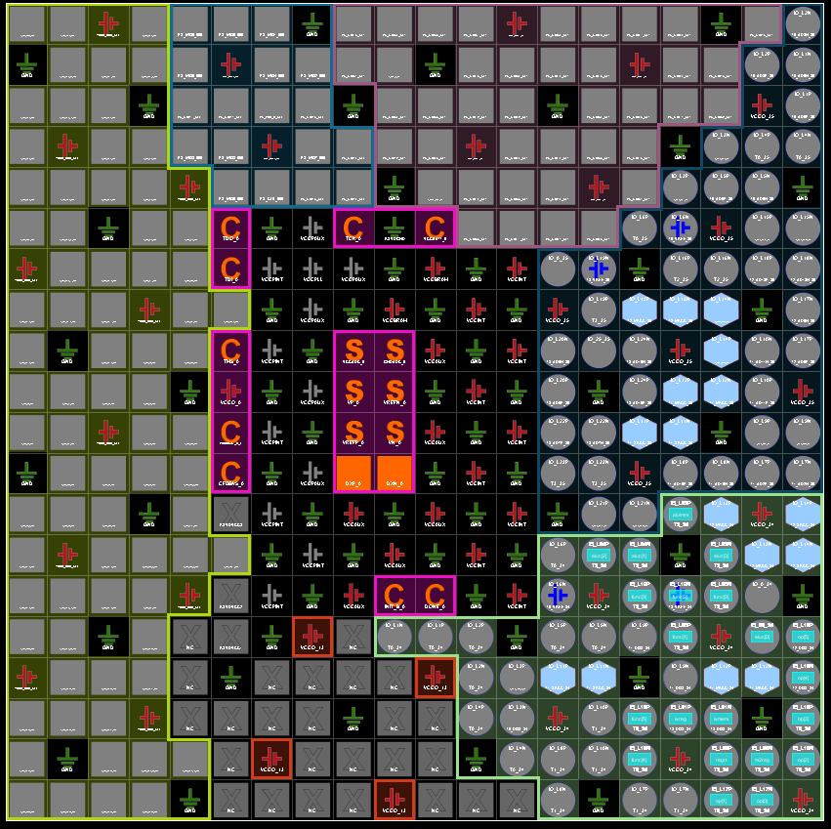

1. Floor Planning

